Nicholas Klacik

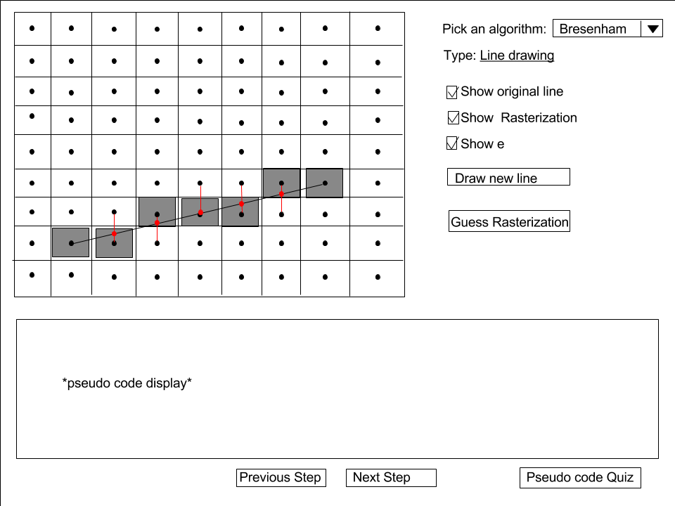

This is what the main screen will look like. The grid will be used as a visual display for rasterization. The user will pick which algorithm they wish to work with via the drop down box in the top-right. The user will have the choice is enable/disable the original line, the rasterization or e on the grid. The ‘draw new line’ button will generate a new random line on the grid. Guess Rasterization will take them to the rasterization quiz screen to test their knowledge. The bottom section will display pseudo code of whatever algorithm they currently have selected, and they will be able to step through the alogorithm via the ‘previous step’ and ‘next step’ buttons. The ‘Pseudo code Quiz’ button will take the user to the Pseudo code Quiz screen.

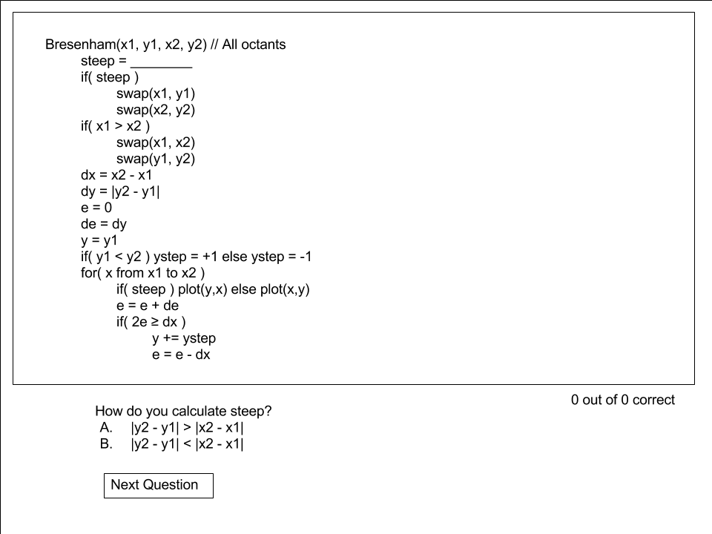

This is what the Pseudo code Quiz screen will look like. The user will be shown incomplete pseudo code, and will be asked multiple choice questions about the missing parts.

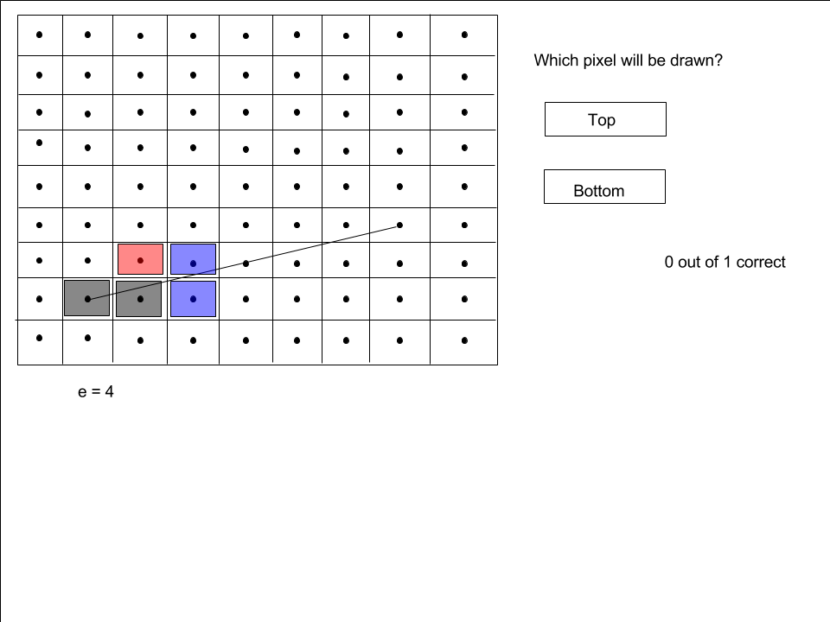

This is what the rasterization quiz screen will look like. The user will have to decide which pixel will be draw next. There choices are highlighted in blue, and incorrect answers will be highlighted red